HYBRID AUTONOMOUS GPS NAVIGATION USING
PATH PLANNING ALGORITHMS

Report submitted to the SASTRA Deemed to be University as the requirement for the course

EIE221: AUTONOMOUS NAVIGATION OF WHEELED MOBILE ROBOTS

Submitted by

P. Dhanush Eswar-127179040
S.R.K. Santhosh-127179051
K.Sathwik-127179030


SCHOOL OF ELECTRICAL & ELECTRONICS ENGINEERING
THANJAVUR, TAMIL NADU, INDIA – 613 401

SCHOOL OF ELECTRICAL & ELECTRONICS ENGINEERING

THANJAVUR – 613 401

Bonafide certificate
This is to certify that the report titled “Hybrid Autonomous GPS navigation using path planning algorithms” was submitted as a requirement for the course, for B.Tech. Artificial Intelligence and Robotics is a bona fide record of the work done during the academic year 2024-25, in the School of Electrical & Electronics Engineering, under my supervision.

Name with Affiliation: Dr B. Vijaya Bhaskar, PhD Date: 08-11-2025

Project Viva voce held on :

SCHOOL OF ELECTRICAL & ELECTRONICS ENGINEERING
THANJAVUR – 613 401

Declaration
I declare that the report titled “Hybrid Autonomous GPS navigation using path planning algorithms” submitted by me is an original work done by me under the guidance of Dr. B. Vijaya Bhaskar, Senior Assistant Professor, School of Electrical & Electronics Engineering, SASTRA Deemed to be University during the seventh semester of the academic year 2024-25, in the School of Electrical & Electronics Engineering. The work is original, and wherever I have used materials from other sources, I have given due credit and cited them in the text of the report. This report has not formed the basis for the award of any degree, diploma, associate-ship, fellowship or other similar title to any candidate of any University.

Acknowledgement

With the blessings of the Almighty, we wish to extend our sincere gratitude to our Honourable Vice Chancellor, Dr S. Vaidhyasubramaniam, SASTRA Deemed to be University, without whom we would not have had such an opportunity.

We also wish to extend our sincere gratitude to our Registrar, Dr R. Chandramouli, SASTRA Deemed to be University, for all the good wishes towards the successful completion of the study.

We owe our hearty thanks to Dr K. Thenmozhi, the Dean, School of Electrical & Electronics Engineering, SASTRA Deemed to be University, for her valuable support and directions given throughout the period of our project work.

We are deeply indebted to my PhD. Supervisor Dr James A. Baskaradas, Associate Professor, and to my Course Co-ordinator, Dr B.Vijaya Bhaskar, Senior Assistant Professor, School of Electrical & Electronics Engineering, SASTRA Deemed to be University, for his valuable guidance, encouragement, and motivation in the successful accomplishment of this project.

We express our heartfelt thanks to all the faculty members, Technical Assistants, and Non-Teaching Staff for their valuable and timely assistance.

Last, but not least, we thank our Parents, Friends and People who are not in the scene but have helped in the successful fulfilment of this project.

Table of contents

Title Page No.
Bonafide certificate ii
Declaration iii
Acknowledgement iv
Abstract v
1. Introduction 1
1.1. Ultrasonic sensor 1
1.2. GPS Navigation 2
1.3. Algorithms 3
- ACO algorithm 3
- Dijkstra algorithm 5
- A* algorithm 6
2. Literature Survey 9
3. Objective 9
4. Proposed methodology 10
        - Overview 10
        - System architecture 10
          - Frontend
          - Backend
          - ESP32 microcontroller
        - Working principle 11
        - Path planning 11
        - Replanning mechanism 12
        - Advantages 12
        - Flow of operation 12
5. Implementation 13
6. Results 37
7. Conclusion and Future Work 37
8. References 38

Abstract

This project presents a real-time autonomous navigation system for robots that relies on coordinate-based map inputs rather than GPS sensors. The system allows users to define a start point and a destination directly on a web-based Leaflet map. Once the points are selected, the robot navigates efficiently using a hybrid path-planning approach that integrates A*, Dijkstra, and Ant Colony Optimisation (ACO) algorithms. These algorithms work together to determine the optimal route, balancing efficiency and adaptability.
The robot is controlled by an ESP32 microcontroller, which receives movement commands from a Python Flask backend. The backend is responsible for calculating the route, managing dynamic replanning, and providing real-time updates on the robot’s position. The robot is equipped with ultrasonic sensors to detect obstacles along its path. When an obstacle is detected, the system dynamically recalculates the route to ensure safe navigation.
The system also includes a real-time visualisation interface, showing the robot’s position, planned route, and detected obstacles on the map. This allows users to monitor the robot’s progress and decision-making process during navigation.
By combining hybrid path-planning algorithms, sensor-driven obstacle detection, and map-based coordinate navigation, the project demonstrates a practical and flexible approach to autonomous navigation in indoor or campus environments. The system is suitable for robotics research, educational demonstrations, and applications where GPS may be unavailable or unreliable.

CHAPTER 1
INTRODUCTION
This project creates an autonomous robot that can navigate to specific coordinates in either a real or simulated environment without a GPS module. The robot uses a mix of path-planning methods, including A*, Dijkstra, and Ant Colony Optimisation, to find the most efficient path between points. It has onboard sensors, like ultrasonic sensors, to detect obstacles and can adjust its route in real time.

The robot is controlled by an ESP32 microcontroller, which works with a Python backend to run the path-planning algorithms. The system can function in a simulated environment for testing or in a real setting with predefined coordinate targets.

Key Features:
-Real-time navigation to predefined coordinates.
- Hybrid path planning with A*, Dijkstra, and ACO.
- Obstacle detection and dynamic replanning.
- ESP32-based wireless robot control.
- Python simulation for testing paths and strategies.
Applications:
This approach is ideal for indoor autonomous robots, warehouse navigation, robotics competitions, and educational simulations where GPS is not available but coordinate-based navigation is needed.

Ultrasonic sensors:
Ultrasonic sensor emits a short burst of ultrasound and measures the time until the echo returns. They encode this measurement as a digital pulse whose width is proportional to distance.
- An ESP32 reads the echo pulse on an open GPIO pin and converts the pulse duration to distance using the speed of sound, typically after sending a 10 µs trigger pulse on another GPIO pin.
Working of the sensor:
- An HC-SR04 styled sensor uses a 10 µs trigger input to start an 8-cycle 40 kHz burst, then raises its echo line for a time proportional to the round-trip light time of the sound wave.
- Typical specs are 2-400 cm range, 15-30° effective angle, and ~15 mA current at 5 V or 3.3 V, with a recommended measurement cycle spacing greater than 60ms to avoid self-echo overlap.
- Time-of-flight distance relation d t. .c/2.
- The HC-SR04 shortcut cm approximately equal to t µs/58.
- where the 't' is echo pulse width and 'c' is speed of sound, which is about 343.2 m/s at 20°C and increases roughly with the square root of absolute temperature.
ESP32 connections:
- Wire Vcc to 3.3V, GND to ground, trig to an ESP32 output GPIO, and Echo to an input GPIO pin.
- The ESP32 GPIO driver lets you configure one pin as an output for Trig and another as an input (optionally with an interrupt) for Echo, enabling precise timing and edge detection in firmware.

GPS Navigation:

1. What is GPS Navigation?
- GPS navigation allows a device to determine its position on Earth based on signals from satellites.
- By precisely knowing the device's latitude and longitude, GPS navigation systems can calculate routes, track movements, and give directions in real time. In robotics, GPS enables outdoor autonomous navigation over large areas.
2. How This Project Simulates GPS Navigation:
- The present project simulates GPS-based navigation without the actual use of any GPS module. Instead of receiving satellite coordinates, the robot will receive predefined coordinates from a digital map interface-such as Leaflet.js.
- The user clicks on the map to select the start point and destination, which are treated as “GPS coordinates.” These coordinates are then utilised in the calculation of the most optimal path using hybrid path-planning algorithms such as A*, Dijkstra, and ACO.
3. Real-time Updates and Navigation:
- The robot's current position is tracked via sensor feedback and communicated to the backend.
- The backend updates the robot's location on the map in real time, similar to GPS tracking.
- Obstacles are detected by sensors, and the system dynamically replans, similar to how a GPS navigation system would recalculate if a road were blocked.
4. Benefits:
- Emulates indoor GPS navigation or navigation within areas not covered by GPS.
- Provides real-time visualisation of the motion of the robot and decision-making. Allows autonomous navigation testing and research without the use of expensive GPS hardware.

Algorithms :

- ACO optimisation:
Ant Colony Optimisation (ACO) is a bio-inspired metaheuristic algorithm based on the foraging behaviour of real ants. Ants find the shortest path between their nest and a food source by depositing a chemical substance called pheromone along their path. Paths with stronger pheromone trails are more likely to be chosen by other ants, allowing the colony to collectively find the optimal route over time.
In robotics and path planning, ACO is used to find optimal or near-optimal routes between a start and end point, especially in dynamic or complex environments.
2. Key Steps of ACO:
- Initialise pheromone values on all paths.
- Each “ant” constructs a path from start to destination based on probabilistic path selection.
- Evaluate the path length or cost.
- Update pheromone levels: increase on good paths, evaporate on all paths.
- Repeat until convergence or maximum iterations.
3. Formulas:
- Probability of choosing the next node $j$from node $i$:
$$P_{ij}=\frac{[τ_{ij}]^{α}⋅[η_{ij}]^{β}}{\sum_{k∈N_{i}}{}[τ_{ik}]^{α}⋅[η_{ik}]^{β}}$$
Where:
- $τ_{ij}$= pheromone level on edge (i, j)
- $η_{ij}=1/d_{ij}$= heuristic information (inverse of distance)
- $α$= weight of pheromone influence
- $β$= weight of heuristic influence
- $N_{i}$= set of feasible neighbouring nodes
- Pheromone update:
$$τ_{ij}←(1-ρ)⋅τ_{ij}+\sum_{k=1}^{m}{}Δτ_{ij}^{k}$$
Where:
- $ρ$= evaporation rate (0 < $ρ$≤ 1)
- $Δτ_{ij}^{k}=Q/L_{k}$if ant $k$used edge (i,j), else 0
- $L_{k}$= total length of path taken by ant $k$
- $Q$= constant factor
4. Advantages in Robot Navigation:
- Finds efficient paths in complex environments.
- Can adapt to dynamic obstacles by updating pheromone trails.
- Works well with hybrid algorithms like A* and Dijkstra for improved efficiency.

Flowchart:
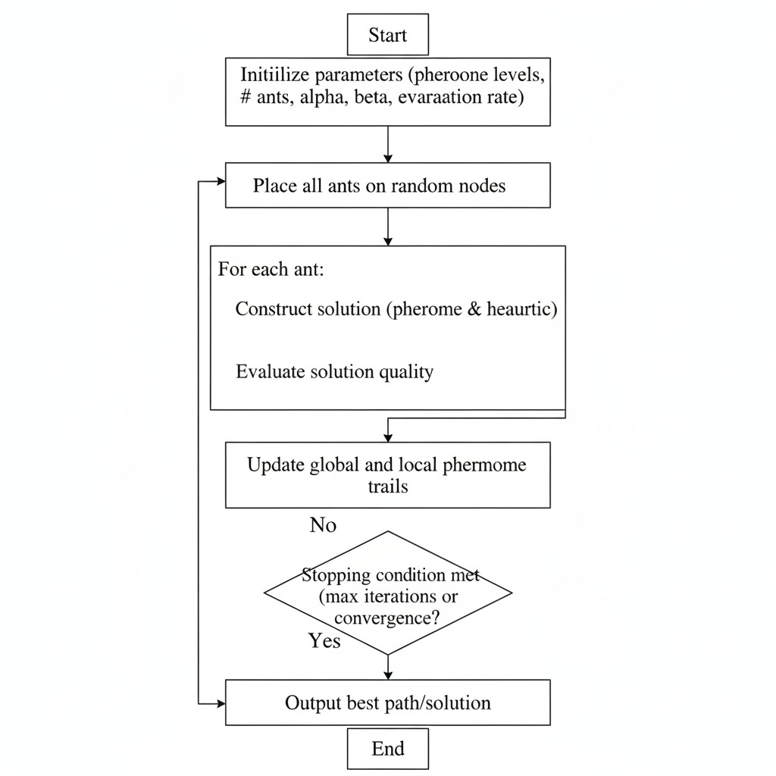

2. Dijkstra algorithm:
Dijkstra’s Algorithm is a classic graph-based shortest path algorithm used to find the minimum distance from a starting node to all other nodes in a weighted graph. In robotics, it is commonly applied for path planning in static environments, where the robot must navigate efficiently from a start point to a destination while avoiding obstacles.
How It Works:
- Assign a tentative distance value to every node: 0 for the start node and ∞ (infinity) for all others.
- Set the start node as the current node.
- For the current node, consider all unvisited neighbours and calculate their tentative distances:
$${\text{tentative_distance}}_{neighbor}={\text{distance}}_{current}+{\text{weight}}_{current,neighbor}$$
- If this tentative distance is less than the previously recorded distance, update it.
- Mark the current node as visited (it will not be checked again).
- Select the unvisited node with the smallest tentative distance as the new current node.
- Repeat steps 3–6 until all nodes are visited or the destination node’s shortest distance is finalised.
Advantages in Robot Navigation:
- Guarantees the shortest path in a static, weighted map.
- Easy to implement for grid-based or coordinate-based maps.
- Can be combined with dynamic obstacle handling by recalculating paths when obstacles are detected.
Limitations:
- Not ideal for very large graphs because it checks all nodes.
- Pure Dijkstra does not account for heuristics like A* does; it only minimises distance.

Flowchart :
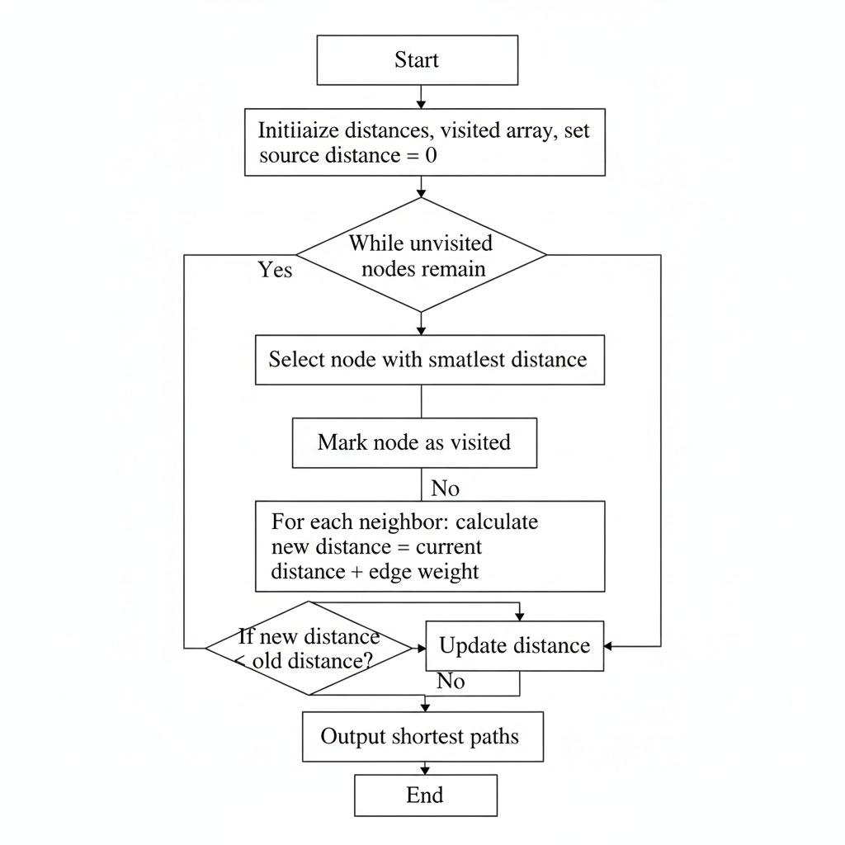

3. A* algorithm:
A* is a graph-based path-planning algorithm that finds the shortest path from a start node to a goal node by combining the advantages of Dijkstra’s Algorithm and heuristic search. It is widely used in robotics for efficient navigation in both grid-based and coordinate-based maps. Unlike Dijkstra, which explores all paths uniformly, A* prioritises paths that are likely to lead to the goal faster.
How it works:
A* uses a cost function. $f(n)$To evaluate nodes:
$$f\left(n\right)=g\left(n\right)+h\left(n\right)$$
Where:
- $g(n)$= actual cost from the start node to the current node $n$
- $h(n)$= heuristic estimate of the cost from $n$to the goal (commonly Euclidean or Manhattan distance)
Algorithm Steps:
- Initialise the open list with the start node.
- While the open list is not empty:
- Select the node with the lowest $f(n)$As the current node.
- If the current node is the goal, reconstruct the path.
- Otherwise, for each neighbour:
- Calculate $g(n)$and $f(n)$.
- If the neighbour is not in the open list or has a lower $g(n)$Update it and add it to the open list.
- Repeat until the goal is reached.
3. Advantages in Robot Navigation:
- Guarantees the shortest path if the heuristic is admissible (never overestimates).
- More efficient than Dijkstra in large maps due to heuristic guidance.
- Easily integrates with dynamic obstacle detection and coordinate-based navigation.

Flowchart: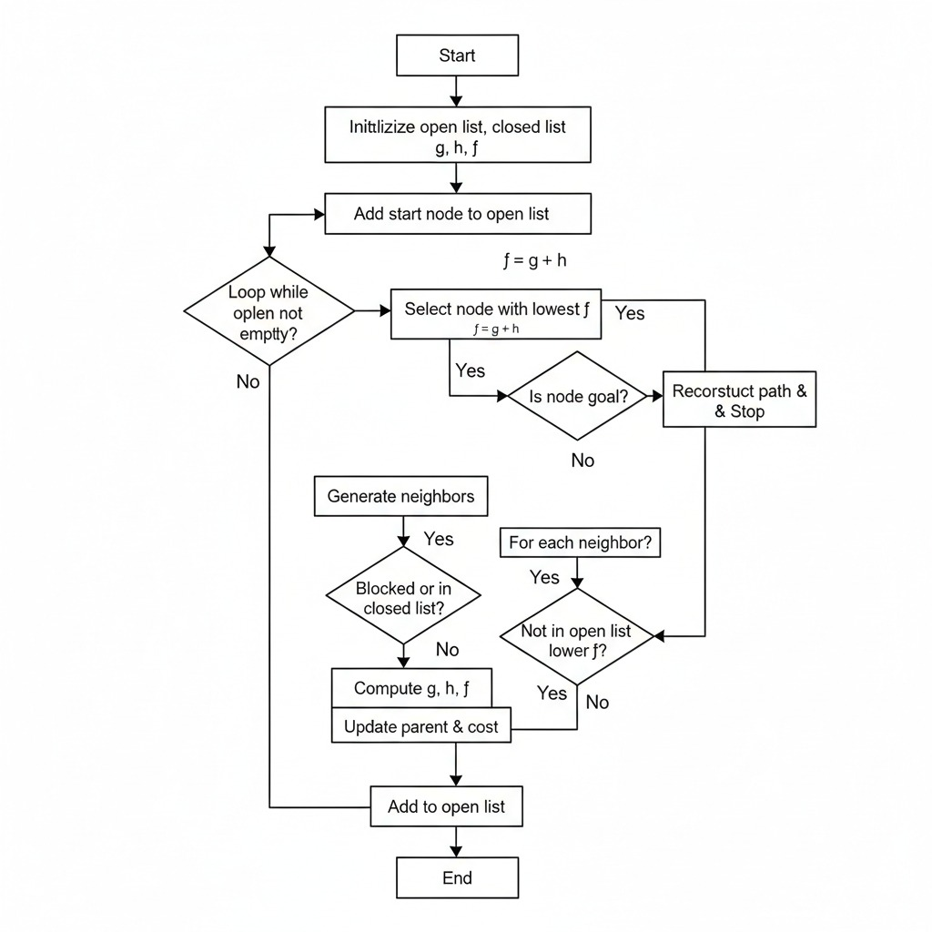
CHAPTER-2
Literature survey
A start Algorithm
The main function in the A star algorithm on which the loop runs and finds its path is thefunction
- f ( n ) = g ( n ) + h ( n )
Where
- f ( n ) is Total estimated cost of the path through n
- g( n ) is the actual cost from start node to the current node and h( n ) is the estimated cost from node n to goal
- As we can see from the h( n ) player an important role in the finding the path from start node to goal node . Hence the choosing the right weight heuristic function is important.
- And using this heuristic function in grid mapping and improving the heuristic function can help us in finding a better solution by increasing the optimality , reducing the time taken for completing the process and reducing our compromises .
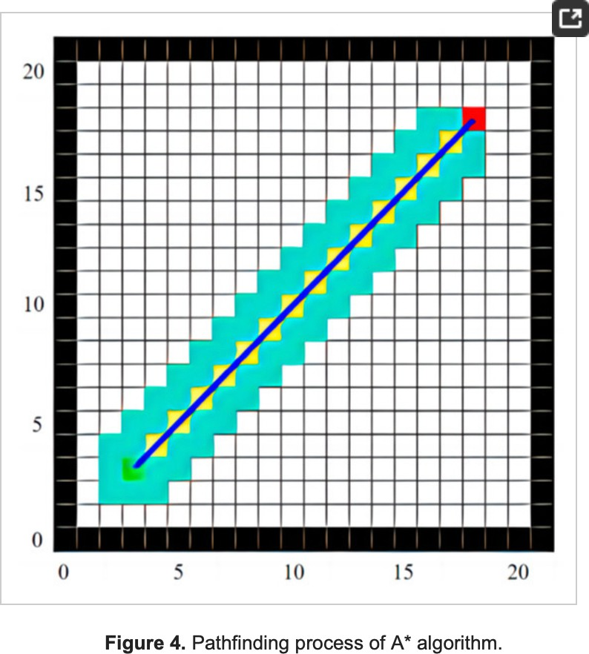
Modelling of grid mapping for A*

Dijikstra Algorithm
- The Dijikstra algorithm is the basic algorithm which we use to find the shortest path from one node to all the other nodes .
- At first we will initialise all the distances from one node to others as infinity and start to start node distance as zero .
- And as the loop runs we take take the edge with the shortest path and save its parent .
- If a new edge with smaller diastance is found then it is updated with the parent .
Author & Year | Title / Study | Contribution
E. W. Dijkstra (1959) | A Note on Two Problems in Connexion with Graphs | Proposed the algorithm for the shortest path problem, forming the basis for many modern routing algorithms.
Zeng et al. (2017) | An Improved Dijkstra Algorithm for Shortest Path Planning | Modified Dijkstra using heuristic pruning to reduce computation time in large-scale maps
Kumar et al. (2020) | Implementation of Dijkstra’s Algorithm for GPS-Based Navigation Systems | Applied the algorithm in real-time GPS mapping for autonomous vehicles to find efficient routes.
Huang et al. (2019) | Optimized Path Planning for Mobile Robots Using Dijkstra and Dynamic Weight Adjustment. | Integrated obstacle detection with adaptive edge weighting to improve navigation accuracy.

Advantages
- Enables real-time path planning and adaptive navigation.
- Minimizes travel distance, energy, and execution time.
- Improves accuracy and safety through dynamic mapping and continuous optimization.
Ant Colony Optimisation
- The principle of ant colony optimisation is to mimic the natural behaviour of the ants in searching their food in a shortest path .
- The main terms to be norrwd are the pheromone , pheromone update , evaporation rate and probability of choosing a path .
- Initialising the ants will play an important role in finding the path .
- The pheromone is the weight of a particular path and in pheromone update we have to change the concentration according to the previous iteration pheromones
- In the evaporation rate the pheromones which have not been visited in a particluar time the pheromones concentration will be made to zero.
COMPARISION TABLE:
Criteria | Ant Colony optimization(AC)) | A* Algorithm | Dijkstra’sAlgorithm
Inspiration | Based on behavior of real ants using pheromone trails to find optimal paths | Uses cost function combining actual distance (g) and heuristic (h) to estimate shortest path | Finds shortest path from source to all nodes using minimum cost approach
Nature of algorithm | Meta-heuristic (probabilistic and bio-inspired) | Heuristic (deterministic + heuristic) | Deterministic (graph-based)
Type of Search | Stochastic (probabilistic search) | Informed search (uses heuristic guidance) | Uninformed search
Computation Time | Higher (depends on number of ants and iterations) | Moderate | Higher for large graphs
Path Accuracy | Near-optimal | Optimal or near-optimal | Always optimal
Best Used For | Dynamic or unknown environments, adaptive robotic navigation | Known environments needing efficiency and accuracy | Static and smaller networks like routing or fixed maps
Example Application | Swarm robotics, autonomous drones | GPS navigation system, robot path planning. | Public transport system, exploration and mapping.

CHAPTER-3
Objective

The main objectives of this project are:

- Design and implement a navigation system based on coordinates, without relying on GPS sensors.
- This will be used to implement multiple path-planning algorithms- A*, Dijkstra, ACO-for efficient and adaptive route generation.
- Develop a python code for route computation and communication with the ESP32 controller.
- To simulate real-time map-based navigation using OpenStreetMap on a web interface.
- The goal is to enable the ESP32 to carry out dynamic obstacle detection and replanning with the help of ultrasonic sensors.
- The efficiency, distance, and computation time of the three algorithms are to be analyzed and compared.
- To ensure smooth, continual, and real-time updating of the robot's position and environment.

CHAPTER-4
Proposed methodology

1. Overview:
The proposed system will develop an autonomous navigation and route-planning system for the mobile robot using GPS-based localization and hybrid path-planning algorithms. This work implements A*, Dijkstra, and Ant Colony Optimization algorithms for path planning; it can communicate with a backend server built using Flask through Wi-Fi communication using ESP32, compute optimal paths, and replan dynamically whenever obstacles are detected in real time.
2. System Architecture:
It is comprised of three major parts:
- Frontend (Interface):
- Displays a live map of the environment.
- The user can choose a starting and ending point.
- Show the ultrasonic sensors readings.
- Backend (Flask Server):
- Receives start and destination coordinates from the frontend.
- Runs the chosen path-planning algorithm: either A*, Dijkstra, or ACO.
- Sends the optimized path along with movement commands to the ESP32.
- Handles real-time replanning in case an obstacle is detected.
- ESP32 Microcontroller Hardware Unit
- It connects to Wi-Fi and communicates with the backend server.
- The robot's motors are actuated according to the movement commands received.
- Uses ultrasonic sensors to detect obstacles dynamically.
- Sends sensor feedback to the backend for replanning.

3. Working Principle
- The user selects the Start and Destination GPS coordinates from the interface.
- These coordinates are sent to the python backend.
- The backend calculates paths by using:
- A* for heuristic-based shortest path
- Dijkstra's Algorithm for the guaranteed optimal path:
- ACO, or Ant Colony Optimization for probabilistic exploration and efficiency.
- It automatically chooses the algorithm that is most efficient (lowest in cost and shortest in time).
- The path chosen is sent to the ESP32 to execute.
- It enables the ESP32 to move the robot along the planned path and continuously monitor its surroundings using ultrasonic sensors.
- In case an obstacle is detected, the backend replans in real time to find an alternative safe route.
- The frontend automatically refreshes, showing the real-time position of the robot, along with its path.
4. Path Planning Algorithms
(a) Dijkstra’s Algorithm
- Finds the shortest path from a source node to all other nodes.
- Works on non-negative weighted graphs.
- Guarantees the optimal solution but is computationally expensive.
(b) A Algorithm*
- Uses both actual cost (g(n)) and estimated cost (h(n)).
- Formula:
$$f(n)=g(n)+h(n)$$
- Faster than Dijkstra due to heuristic guidance.
(c) Ant Colony Optimization (ACO)
- Simulates ant foraging behavior to find optimal paths.
- Relies on pheromone trails to guide future searches.
- Probability of moving from node i to j:
$$P_{ij}=\frac{(τ_{ij})^{α}(η_{ij})^{β}}{\sum_{k∈allowed}{}(τ_{ik})^{α}(η_{ik})^{β}}$$
where:
  - $τ_{ij}$: pheromone strength
  - $η_{ij}$: visibility (1/distance)
  - $α,β$: control parameters
5. Replanning Mechanism
- When the ESP32 finds a new obstacle with the use of ultrasonic sensors, it sends a signal to the backend.
- The python code recalculates the optimal path using all three algorithms.
- The algorithm producing the fastest and shortest route is selected automatically.
- The robot seamlessly resumes its motion along the new path.
6. Advantages
- Combines accuracy (Dijkstra), *efficiency (A)**, and adaptability (ACO).
- Real-time replanning makes it suitable for dynamic environments.
- Communication between ESP32 and backend ensures continuous feedback control.
- GPS-based localization enables autonomous outdoor navigation.
7. Flow of Operations
- Initialize GPS and Wi-Fi connection.
- Receive start and goal coordinates.
- Compute path using A*, Dijkstra, and ACO.
- Select the optimal route based on performance.
- Send commands to ESP32 → motors move the robot.
- Observe environment using sensors.
- Trigger replanning if obstacles appear.
- Arrive at destination.

CHAPTER-5
Implementation

ESP32 CODE:
#include <WiFi.h>
#include <WebServer.h>
// ==== Wi-Fi credentials ====
const char* ssid = "Dhanush's M34 5G"; // <-- Put your SSID here
const char* password = "7569576743"; // <-- Put your password here

// ==== Motor pins ====
#define IN1 32
#define IN2 33
#define EN_A 25 // Connect to ENA on motor driver
#define IN3 18
#define IN4 19
#define EN_B 26 // Connect to ENB on motor driver
// ==== Ultrasonic Sensors ====
#define TRIG_LEFT 12
#define ECHO_LEFT 13
#define TRIG_RIGHT 4
#define ECHO_RIGHT 5
// ==== PWM Configuration ====
int currentSpeed = 150; // Default speed (0-255)
WebServer server(80);
bool movementActive = false;
unsigned long movementEndMs = 0;
char movementCmd = 'S';
const unsigned long MOVE_FORWARD_MS = 500;
const unsigned long MOVE_TURN_MS = 400;
const unsigned long MOVE_BACK_MS = 500;
// ==== Motor functions (using analogWrite) ====
void motorStop() {
digitalWrite(IN1, LOW); digitalWrite(IN2, LOW);
digitalWrite(IN3, LOW); digitalWrite(IN4, LOW);
analogWrite(EN_A, 0); // Set speed to 0
analogWrite(EN_B, 0); // Set speed to 0
}
void motorTurnRight() {
digitalWrite(IN1, HIGH); digitalWrite(IN2, LOW); // Motor A Fwd
digitalWrite(IN3, HIGH); digitalWrite(IN4, LOW); // Motor B Rev
analogWrite(EN_A, currentSpeed); // Set speed
analogWrite(EN_B, currentSpeed); // Set speed
}
void motorBackward() {
digitalWrite(IN1, LOW); digitalWrite(IN2, HIGH); // Motor A Rev
digitalWrite(IN3, HIGH); digitalWrite(IN4, LOW); // Motor B Rev
analogWrite(EN_A, currentSpeed); // Set speed
analogWrite(EN_B, currentSpeed); // Set speed
}
void motorTurnLeft() {
digitalWrite(IN1, LOW); digitalWrite(IN2, HIGH); // Motor A Rev
digitalWrite(IN3, LOW); digitalWrite(IN4, HIGH); // Motor B Fwd
analogWrite(EN_A, currentSpeed); // Set speed
analogWrite(EN_B, currentSpeed); // Set speed
}
void motorForward() {
digitalWrite(IN1, HIGH); digitalWrite(IN2, LOW); // Motor A Fwd
digitalWrite(IN3, LOW); digitalWrite(IN4, HIGH); // Motor B Fwd
analogWrite(EN_A, currentSpeed); // Set speed
analogWrite(EN_B, currentSpeed); // Set speed
}
void startMovement(char cmd) {
movementCmd = cmd;
if (cmd == 'F') {
motorForward();
movementEndMs = millis() + MOVE_FORWARD_MS;
movementActive = true;
} else if (cmd == 'B') {
motorBackward();
movementEndMs = millis() + MOVE_BACK_MS;
movementActive = true;
} else if (cmd == 'L') {
motorTurnLeft();
movementEndMs = millis() + MOVE_TURN_MS;
movementActive = true;
} else if (cmd == 'R') {
motorTurnRight();
movementEndMs = millis() + MOVE_TURN_MS;
movementActive = true;
} else {
motorStop();
movementActive = false;
movementCmd = 'S';
}
}
float getDistance(int trigPin, int echoPin) {
digitalWrite(trigPin, LOW);
delayMicroseconds(2);
digitalWrite(trigPin, HIGH);
delayMicroseconds(10);
digitalWrite(trigPin, LOW);
long duration = pulseIn(echoPin, HIGH, 20000);
float distance = duration * 0.0343 / 2;
if (distance == 0 || distance > 400) distance = 400;
return distance;
}
// ==== Compact HTML ====
const char INDEX_HTML[] PROGMEM = R"HTML(
<!DOCTYPE html><html><head><meta charset="UTF-8"><meta name="viewport" content="width=device-width,initial-scale=1.0">
<title>Robot Control</title><style>*{margin:0;padding:0;box-sizing:border-box}body{font-family:Arial,sans-serif;background:linear-gradient(135deg,#667eea 0%,#764ba2 100%);min-height:100vh;padding:10px}.container{max-width:600px;margin:0 auto;background:#fff;border-radius:15px;box-shadow:0 10px 30px rgba(0,0,0,.3);overflow:hidden}.header{background:linear-gradient(135deg,#667eea 0%,#764ba2 100%);color:#fff;padding:20px;text-align:center}.header h1{font-size:24px}.content{padding:20px}.section{margin-bottom:20px;padding:15px;background:#f8f9fa;border-radius:10px}.section-title{font-size:16px;font-weight:600;color:#495057;margin-bottom:10px}.sensor-grid{display:grid;grid-template-columns:1fr 1fr;gap:10px}.sensor-card{background:#fff;padding:15px;border-radius:8px;text-align:center;box-shadow:0 2px 5px rgba(0,0,0,.1)}.sensor-label{font-size:12px;color:#6c757d;margin-bottom:5px}.sensor-value{font-size:28px;font-weight:700;color:#667eea}.info-row{display:flex;justify-content:space-between;padding:10px;background:#fff;border-radius:5px;margin-bottom:8px;font-size:14px}.status-indicator{display:inline-block;width:10px;height:10px;border-radius:50%;margin-right:5px}.status-active{background:#28a745}.status-inactive{background:#dc3545}.controls{display:grid;grid-template-columns:repeat(3,1fr);gap:8px;margin-top:10px}.btn{padding:12px;border:none;border-radius:8px;font-weight:600;cursor:pointer;transition:.2s;color:#fff}.btn-control{background:#667eea}.btn-control:active{transform:scale(.95)}#forward{grid-column:2}#left{grid-row:2}#stop{grid-column:2;grid-row:2;background:#dc3545}#right{grid-column:3;grid-row:2}#backward{grid-column:2;grid-row:3}.btn-emergency{background:#dc3545;width:100%;margin-top:10px}.speed-control{display:flex;align-items:center;gap:10px}#speed-val{font-size:18px;font-weight:600;width:40px;text-align:center}.slider{flex-grow:1;height:10px;accent-color:#667eea}</style></head><body>
<div class="container"><div class="header"><h1>🤖 Robot Control</h1></div><div class="content">
<div class="section"><div class="section-title">📡 Sensors</div><div class="sensor-grid">
<div class="sensor-card"><div class="sensor-label">LEFT</div><div class="sensor-value" id="left">--</div></div>
<div class="sensor-card"><div class="sensor-label">RIGHT</div><div class="sensor-value" id="right">--</div></div>
</div></div>
<div class="section"><div class="section-title">📍 Status</div>
<div class="info-row"><span>Status</span><span><span class="status-indicator status-inactive" id="ind"></span><span id="stat">Ready</span></span></div>
<div class="info-row"><span>Command</span><span id="cmd">STOP</span></div>
</div>
<div class="section"><div class="section-title">⚡ Speed</div><div class="speed-control"><span id="speed-val">200</span><input type="range" min="0" max="255" value="200" class="slider" id="speedSlider"></div></div>
<div class="section"><div class="section-title">🎮 Controls</div>
<div class="controls">
<button class="btn btn-control" id="forward" onclick="send('F')">&uarr;</button>
<button class="btn btn-control" id="left" onclick="send('L')">&larr;</button>
<button class="btn btn-control" id="stop" onclick="send('S')">&blacksquare;</button>
<button class="btn btn-control" id="right" onclick="send('R')">&rarr;</button>
<button class="btn btn-control" id="backward" onclick="send('B')">&darr;</button>
</div><button class="btn btn-emergency" onclick="stop()">EMERGENCY STOP</button>
</div></div></div>
<script>
setInterval(updateSensors,500);setInterval(updateStatus,1000);
async function updateSensors(){try{const r=await fetch('/ultrasonic');const d=await r.json();
document.getElementById('left').textContent=d.left.toFixed(1);
document.getElementById('right').textContent=d.right.toFixed(1);
document.getElementById('left').style.color=d.left<25?'#dc3545':d.left<50?'#ffc107':'#28a745';
document.getElementById('right').style.color=d.right<25?'#dc3545':d.right<50?'#ffc107':'#28a745';
}catch(e){}}
async function updateStatus(){try{const r=await fetch('/status');const s=await r.text();
document.getElementById('ind').className=s==='BUSY'?'status-indicator status-active':'status-indicator status-inactive';
}catch(e){}}
async function send(c){try{await fetch('/move?dir='+c);
document.getElementById('cmd').textContent=c==='F'?'FORWARD':c==='B'?'BACKWARD':c==='L'?'LEFT':c==='R'?'RIGHT':'STOP';
}catch(e){alert('Failed!')}}
async function stop(){try{await fetch('/stop');document.getElementById('cmd').textContent='STOPPED';}catch(e){}}
const speedSlider=document.getElementById('speedSlider');const speedValEl=document.getElementById('speed-val');speedSlider.oninput=()=>{speedValEl.textContent=speedSlider.value;};speedSlider.onchange=async()=>{try{await fetch('/speed?val='+speedSlider.value);}catch(e){alert('Speed set failed!');}};
updateSensors();updateStatus();
</script></body></html>
)HTML";
// ==== Handlers ====
void handleRoot() {
server.send(200, "text/html", INDEX_HTML);
}
void handleMove() {
String dir = server.arg("dir");
if (dir.length() == 0) {
server.send(400, "text/plain", "Missing dir");
return;
}
char d = dir.charAt(0);
if (d == 'F' || d == 'B' || d == 'L' || d == 'R' || d == 'S') {
startMovement(d);
server.send(200, "text/plain", "OK");
} else {
server.send(400, "text/plain", "Bad dir");
}
}
void handleSpeed() {
String val = server.arg("val");
if (val.length() == 0) {
server.send(400, "text/plain", "Missing val");
return;
}
int speed = val.toInt();
if (speed < 0) speed = 0;
if (speed > 255) speed = 255;
currentSpeed = speed;
// Update speed immediately if a movement is active
if (movementActive) {
analogWrite(EN_A, currentSpeed);
analogWrite(EN_B, currentSpeed);
}
server.send(200, "text/plain", "Speed set to " + String(currentSpeed));
}
void handleUltrasonic() {
float left = getDistance(TRIG_LEFT, ECHO_LEFT);
float right = getDistance(TRIG_RIGHT, ECHO_RIGHT);
String json = "{\"left\":" + String(left, 1) + ",\"right\":" + String(right, 1) + "}";
server.send(200, "application/json", json);
}
void handleStatus() {
server.send(200, "text/plain", movementActive ? "BUSY" : "DONE");
}
void handleStop() {
motorStop();
movementActive = false;
movementCmd = 'S';
movementEndMs = 0;
server.send(200, "text/plain", "STOPPED");
}
// ==== Setup ====
void setup() {
Serial.begin(115200);
delay(100); // Small delay for stability
pinMode(IN1, OUTPUT);
pinMode(IN2, OUTPUT);
pinMode(EN_A, OUTPUT);
pinMode(IN3, OUTPUT);
pinMode(IN4, OUTPUT);
pinMode(EN_B, OUTPUT);
pinMode(TRIG_LEFT, OUTPUT);
pinMode(ECHO_LEFT, INPUT);
pinMode(TRIG_RIGHT, OUTPUT);
pinMode(ECHO_RIGHT, INPUT);
motorStop(); // This will now set speed to 0 using analogWrite
Serial.println("\nConnecting WiFi...");
WiFi.mode(WIFI_STA);
WiFi.begin(ssid, password);
int attempts = 0;
while (WiFi.status() != WL_CONNECTED && attempts < 40) {
delay(500);
Serial.print(".");
attempts++;
}
if (WiFi.status() == WL_CONNECTED) {
Serial.println("\nConnected!");
Serial.print("IP: ");
Serial.println(WiFi.localIP());
Serial.println("Open browser: http://" + WiFi.localIP().toString());
} else {
Serial.println("\nWiFi failed!");
}
server.on("/", handleRoot);
server.on("/move", handleMove);
server.on("/speed", handleSpeed);
server.on("/ultrasonic", handleUltrasonic);
server.on("/status", handleStatus);
server.on("/stop", handleStop);
server.begin();
Serial.println("Ready!");
}
// ==== Loop ====
void loop() {
server.handleClient();
if (movementActive && (long)(millis() - movementEndMs) >= 0) {
motorStop();
movementActive = false;
movementCmd = 'S';
}
delay(1);
}
CIRCUIT CONNECTIONS DIAGRAM:

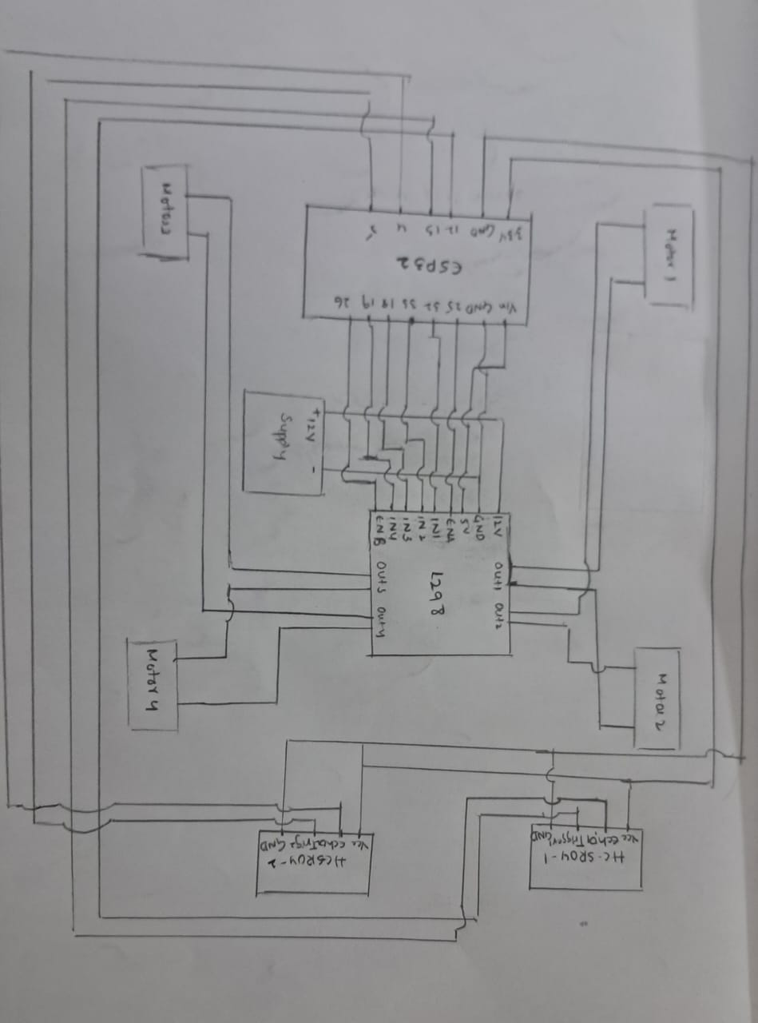

PYTHON CODE:
import math
import random
import time
import heapq
import requests
import pygame
import numpy as np
from typing import Tuple, List, Dict, Optional, Any
# ---------------------------------------------------------------------
# CONFIGURATION CLASS
# ---------------------------------------------------------------------
class Config:
"""Holds all static configuration values."""
# ESP32 Communication
ESP32_IP = "192.168.202.1" # <<<--- CHECK YOUR ESP32's IP ADDRESS HERE
MOVE_URL = f"http://{ESP32_IP}/move"
ULTRA_URL = f"http://{ESP32_IP}/ultrasonic"
REQUEST_TIMEOUT = 0.7 # Seconds
# Grid & Simulation
GRID_SIZE = 50
CELL_SIZE = 12
INITIAL_OBSTACLE_RATE = 0.01
DYNAMIC_OBS_PROB = 0.02
FPS = 10
SELECTION_FPS = 30
# GPS Configuration
GPS_BASE_LAT = 10.732500
GPS_BASE_LON = 79.015054 # Base longitude
GPS_LAT_STEP = 0.0001 # Each grid cell = ~11 meters latitude
GPS_LON_STEP = 0.0001 # Each grid cell = ~11 meters longitude
# Robot Movement
MOVE_STEP_TIME = 0.55 # Time for one "Forward" or "Back"
TURN_TIME = 0.45 # Time for one "Left" or "Right"
STOP_PAUSE = 1 # Extra pause after stopping for an obstacle
# Sensor
ULTRASONIC_THRESHOLD_CM = 25.0
# ACO Parameters
ACO_ANTS = 18
ACO_ITERS = 16
ALPHA = 1.0 # Pheromone importance
BETA = 3.0 # Heuristic importance
EVAP = 0.4 # Evaporation rate
Q = 40.0 # Pheromone deposit strength
# Colors
WHITE = (255, 255, 255)
BLACK = (0, 0, 0)
GRAY = (180, 180, 180)
GREEN = (0, 200, 0)
RED = (200, 0, 0)
DARK_RED = (150, 0, 0)
BLUE = (0, 120, 255)
PURPLE = (200, 0, 255)
YELLOW = (255, 255, 0)
ORANGE = (255, 165, 0)
START_GREEN = (0, 180, 0)
GOAL_ORANGE = (180, 100, 0)
# ---------------------------------------------------------------------
# GPS & GRID UTILITY FUNCTIONS
# ---------------------------------------------------------------------
Cell = Tuple[int, int]
GPSCoord = Tuple[float, float]
def cell_to_gps(cell: Cell) -> GPSCoord:
"""Convert grid cell (x, y) to GPS coordinates (lat, lon)"""
x, y = cell
lat = Config.GPS_BASE_LAT + (Config.GRID_SIZE - 1 - y) * Config.GPS_LAT_STEP
lon = Config.GPS_BASE_LON + x * Config.GPS_LON_STEP
return (lat, lon)
def gps_to_cell(lat: float, lon: float) -> Cell:
"""Convert GPS coordinates to grid cell (x, y)"""
x = int(round((lon - Config.GPS_BASE_LON) / Config.GPS_LON_STEP))
y = Config.GRID_SIZE - 1 - int(round((lat - Config.GPS_BASE_LAT) / Config.GPS_LAT_STEP))
return (x, y)
def gps_distance(gps1: GPSCoord, gps2: GPSCoord) -> float:
"""Calculate distance between two GPS points in meters (Haversine formula)"""
lat1, lon1 = gps1
lat2, lon2 = gps2
R = 6371000 # Earth radius in meters
phi1 = math.radians(lat1)
phi2 = math.radians(lat2)
dphi = math.radians(lat2 - lat1)
dlambda = math.radians(lon2 - lon1)
a = math.sin(dphi/2)*2 + math.cos(phi1) * math.cos(phi2) * math.sin(dlambda/2)*2
c = 2 * math.atan2(math.sqrt(a), math.sqrt(1-a))
return R * c
def in_bounds(cell: Cell) -> bool:
x, y = cell
return 0 <= x < Config.GRID_SIZE and 0 <= y < Config.GRID_SIZE
def neighbors4(cell: Cell) -> List[Cell]:
x, y = cell
neighbors = []
for dx, dy in ((1,0),(-1,0),(0,1),(-1,0)):
nx, ny = x+dx, y+dy
if in_bounds((nx,ny)):
neighbors.append((nx, ny))
return neighbors
def manhattan(a: Cell, b: Cell) -> int:
return abs(a[0]-b[0]) + abs(a[1]-b[1])
def euclid(a: Cell, b: Cell) -> float:
return math.hypot(a[0]-b[0], a[1]-b[1])
# ---------------------------------------------------------------------
# MAP / GRID CLASS
# ---------------------------------------------------------------------
class Grid:
"""Manages the 2D map grid state."""
def _init_(self, n: int, density: float, seed: int = 0):
self.n = n
random.seed(seed)
# 0=Free, 1=Static Obstacle, 2=Dynamic Obstacle
self.grid = np.zeros((n,n), dtype=np.uint8)
for y in range(n):
for x in range(n):
if random.random() < density:
self.grid[y,x] = 1
def is_free(self, cell: Cell) -> bool:
x,y = cell
return in_bounds(cell) and self.grid[y,x] == 0

# **** THIS FUNCTION IS NOW CORRECTED ****
def set_dynamic(self, cell: Cell):
if in_bounds(cell):
x, y = cell # <--- THIS LINE WAS MISSING
self.grid[y,x] = 2
# **** THIS FUNCTION IS NOW CORRECTED ****
def clear(self, cell: Cell):
if in_bounds(cell):
x, y = cell # <--- THIS LINE WAS MISSING
self.grid[y,x] = 0
def random_free_cell(self) -> Optional[Cell]:
free = np.argwhere(self.grid == 0)
if len(free) == 0:
return None
y,x = free[random.randrange(len(free))]
return (int(x), int(y))
# ---------------------------------------------------------------------
# ROBOT SIMULATION STATE CLASS
# ---------------------------------------------------------------------
class SimRobot:
"""Manages the robot's simulated state (position, orientation)."""
# E, N, W, S
VECTORS = [(1,0),(0,-1),(-1,0),(0,1)]
def _init_(self, grid: Grid, start: Cell, goal: Cell, orient: int = 1):
self.grid = grid
self.pos = start
self.goal = goal
self.orient = orient % 4 # Default 1 = North
self.history = [start]
def front_cell(self) -> Cell:
v = self.VECTORS[self.orient]
return (self.pos[0] + v[0], self.pos[1] + v[1])
def step_to(self, cell: Cell) -> bool:
"""Updates robot's simulated position and orientation."""
if not in_bounds(cell) or not self.grid.is_free(cell):
return False
# Update orientation based on move direction
dx = cell[0] - self.pos[0]; dy = cell[1] - self.pos[1]
for i,v in enumerate(self.VECTORS):
if (dx,dy) == v:
self.orient = i
break
self.pos = cell
self.history.append(cell)
return True
def turn_left(self):
self.orient = (self.orient + 1) % 4
def turn_right(self):
self.orient = (self.orient - 1) % 4
# ---------------------------------------------------------------------
# ROBOT HTTP CONTROLLER CLASS
# ---------------------------------------------------------------------
class RobotController:
"""Handles all HTTP communication with the physical ESP32 robot."""
def _init_(self, move_url: str, ultra_url: str, timeout: float):
self.move_url = move_url
self.ultra_url = ultra_url
self.timeout = timeout
def move(self, cmd: str) -> bool:
"""Sends a move command (F, L, R, S) to the ESP32."""
try:
requests.get(self.move_url, params={"dir": cmd}, timeout=self.timeout)
print(f" CMD: {cmd}")
# Add sleep after sending command to let robot execute
if cmd == "F" or cmd == "B":
time.sleep(Config.MOVE_STEP_TIME)
elif cmd == "L" or cmd == "R":
time.sleep(Config.TURN_TIME)
elif cmd == "S":
time.sleep(0.1) # Short pause for stop
return True
except Exception as e:
print(f" CMD: {cmd} FAILED: {e}")
return False
def get_sensor_data(self) -> Dict[str, Any]:
"""Gets ultrasonic data from ESP32. Returns a fallback on error."""
try:
r = requests.get(self.ultra_url, timeout=self.timeout)
data = r.json()
left = float(data.get("left", 999.0))
right = float(data.get("right", 999.0))
obs = (left <= Config.ULTRASONIC_THRESHOLD_CM) or (right <= Config.ULTRASONIC_THRESHOLD_CM)
print(f" Sensor (L/R): {left:.1f}cm / {right:.1f}cm. Obstacle: {obs}")
return {"left": left, "right": right, "obstacle": obs}
except Exception as e:
print(f" Sensor Error: {e}. Fallback: No obstacle.")
# Fallback (simulating no obstacle)
return {"left": 999.0, "right": 999.0, "obstacle": False}

# ---------------------------------------------------------------------
# PATHFINDING CLASS
# ---------------------------------------------------------------------
class PathPlanner:
"""Contains all pathfinding algorithms (A*, Dijkstra, ACO)."""
def _init_(self, grid: Grid, config: Config):
self.grid = grid
self.config = config
def plan_best_path(self, start: Cell, goal: Cell) -> (Dict[str, List[Cell]], List[Cell], str):
"""Runs all planners and returns the best path."""
p_a = self._astar(start, goal)
p_d = self._dijkstra(start, goal)
p_c = self._aco(start, goal)
paths = {"A*": p_a, "Dijkstra": p_d, "ACO": p_c}
lengths = {k:(len(v) if v else float('inf')) for k,v in paths.items()}
best_algo = min(lengths, key=lengths.get)
best_path = paths[best_algo]
print(f"Replanning. Best algo: {best_algo} (len={lengths[best_algo]})")
return paths, best_path, best_algo
def _astar(self, start: Cell, goal: Cell) -> Optional[List[Cell]]:
openq = []
heapq.heappush(openq, (manhattan(start,goal), start)) # f-score, cell
came = {start: None}
gscore = {start: 0}
while openq:
_, cur = heapq.heappop(openq)

if cur == goal:
path = []
while cur:
path.append(cur)
cur = came[cur]
return list(reversed(path))
for n in neighbors4(cur):
if not self.grid.is_free(n):
continue
tentative_g = gscore[cur] + 1
if tentative_g < gscore.get(n, float('inf')):
came[n] = cur
gscore[n] = tentative_g
f_score = tentative_g + manhattan(n, goal)
heapq.heappush(openq, (f_score, n))
return None
def _dijkstra(self, start: Cell, goal: Cell) -> Optional[List[Cell]]:
pq = [(0, start)] # cost, cell
came = {start: None}
dist = {start: 0}
while pq:
d, cur = heapq.heappop(pq)
if d > dist.get(cur, float('inf')):
continue
if cur == goal:
path = []
while cur:
path.append(cur)
cur = came[cur]
return list(reversed(path))
for n in neighbors4(cur):
if not self.grid.is_free(n):
continue

nd = d + 1
if nd < dist.get(n, float('inf')):
dist[n] = nd
came[n] = cur
heapq.heappush(pq, (nd, n))
return None
def _aco(self, start: Cell, goal: Cell) -> Optional[List[Cell]]:
nodes = [(x,y) for x in range(self.grid.n) for y in range(self.grid.n) if self.grid.is_free((x,y))]
if start not in nodes or goal not in nodes:
return None
pher = {n: 1.0 for n in nodes}
best_path = None
best_len = float('inf')
for _ in range(self.config.ACO_ITERS):
iter_paths = []
for _ in range(self.config.ACO_ANTS):
path = [start]
visited = {start}
cur = start
for _ in range(self.grid.n * 5): # Max steps per ant
if cur == goal:
break
options = [nb for nb in neighbors4(cur) if self.grid.is_free(nb) and nb not in visited]
if not options:
break # Ant is stuck
probs = []
for opt in options:
tau = pher.get(opt, 1.0) ** self.config.ALPHA
eta = (1.0 / (euclid(opt, goal) + 1e-6)) ** self.config.BETA
probs.append(tau * eta)
s = sum(probs)
if s == 0:
break # No valid moves
probs = [p/s for p in probs]
nxt = random.choices(options, weights=probs)[0]
path.append(nxt)
visited.add(nxt)
cur = nxt
if path[-1] == goal:
iter_paths.append(path)
L = len(path)
if L < best_len:
best_len = L
best_path = path
# Evaporation
for k in pher:
pher[k] *= (1 - self.config.EVAP)
# Deposition
for p in iter_paths:
L = len(p)
deposit = self.config.Q / L
for node in p:
if node in pher:
pher[node] += deposit
return best_path
# ---------------------------------------------------------------------
# VISUALIZATION CLASS
# ---------------------------------------------------------------------
class Visualizer:
"""Handles all Pygame window and drawing operations."""
def _init_(self, config: Config):
pygame.init()
self.config = config
self.c = config # shorter alias
self.win = pygame.display.set_mode((self.c.GRID_SIZE * self.c.CELL_SIZE, self.c.GRID_SIZE * self.c.CELL_SIZE + 60))
pygame.display.set_caption("GPS-Based Hybrid Simulator")
self.font = pygame.font.SysFont(None, 18)
self.font_small = pygame.font.SysFont(None, 14)
self.clock = pygame.time.Clock()
def _draw_grid(self, grid: Grid):
for y in range(grid.n):
for x in range(grid.n):
v = grid.grid[y,x]
color = self.c.WHITE if v == 0 else (self.c.RED if v == 1 else self.c.DARK_RED)
pygame.draw.rect(self.win, color, (x*self.c.CELL_SIZE, y*self.c.CELL_SIZE, self.c.CELL_SIZE-1, self.c.CELL_SIZE-1))
def draw_selection_phase(self, grid: Grid, start_cell: Cell, goal_cell: Cell):
self.win.fill(self.c.WHITE)
self._draw_grid(grid)
if start_cell:
sx, sy = start_cell
pygame.draw.rect(self.win, self.c.GREEN, (sx*self.c.CELL_SIZE, sy*self.c.CELL_SIZE, self.c.CELL_SIZE-1, self.c.CELL_SIZE-1))
gps = cell_to_gps(start_cell)
text = self.font_small.render(f"S: {gps[0]:.6f}, {gps[1]:.6f}", True, self.c.BLACK)
self.win.blit(text, (sx*self.c.CELL_SIZE, sy*self.c.CELL_SIZE - 12))

if goal_cell:
gx, gy = goal_cell
pygame.draw.rect(self.win, self.c.ORANGE, (gx*self.c.CELL_SIZE, gy*self.c.CELL_SIZE, self.c.CELL_SIZE-1, self.c.CELL_SIZE-1))
gps = cell_to_gps(goal_cell)
text = self.font_small.render(f"G: {gps[0]:.6f}, {gps[1]:.6f}", True, self.c.BLACK)
self.win.blit(text, (gx*self.c.CELL_SIZE, gy*self.c.CELL_SIZE - 12)
# Instructions
y_offset = self.c.GRID_SIZE * self.c.CELL_SIZE + 5
text1 = self.font.render("Left Click: Set START | Right Click: Set GOAL | SPACE: Begin", True, self.c.BLACK)
self.win.blit(text1, (10, y_offset))
if start_cell and goal_cell:
dist_m = gps_distance(cell_to_gps(start_cell), cell_to_gps(goal_cell))
text2 = self.font.render(f"Distance: {dist_m:.1f}m", True, self.c.BLUE)
self.win.blit(text2, (10, y_offset + 20))
pygame.display.flip()
def draw_navigation_phase(self, grid: Grid, paths: Dict, chosen_path: List, robot: SimRobot):
self.win.fill(self.c.WHITE)
self._draw_grid(grid)
# Draw alternative paths
colors = {"A*":self.c.YELLOW, "Dijkstra":self.c.GRAY, "ACO":self.c.BLUE}
for name, p in paths.items():
if p:
pts = [(x*self.c.CELL_SIZE + self.c.CELL_SIZE//2, y*self.c.CELL_SIZE + self.c.CELL_SIZE//2) for (x,y) in p]
if len(pts) > 1:
pygame.draw.lines(self.win, colors.get(name, self.c.GRAY), False, pts, 2)
# Draw chosen path
if chosen_path:
pts = [(x*self.c.CELL_SIZE + self.c.CELL_SIZE//2, y*self.c.CELL_SIZE + self.c.CELL_SIZE//2) for (x,y) in chosen_path]
if len(pts) > 1:
pygame.draw.lines(self.win, self.c.GREEN, False, pts, 3)
# Draw start/goal
sx, sy = robot.history[0]
gx, gy = robot.goal
pygame.draw.rect(self.win, self.c.START_GREEN, (sx*self.c.CELL_SIZE, sy*self.c.CELL_SIZE, self.c.CELL_SIZE-1, self.c.CELL_SIZE-1))
pygame.draw.rect(self.win, self.c.GOAL_ORANGE, (gx*self.c.CELL_SIZE, gy*self.c.CELL_SIZE, self.c.CELL_SIZE-1, self.c.CELL_SIZE-1)
# Draw robot
rx, ry = robot.pos
pygame.draw.circle(self.win, self.c.PURPLE, (rx*self.c.CELL_SIZE + self.c.CELL_SIZE//2, ry*self.c.CELL_SIZE + self.c.CELL_SIZE//2), self.c.CELL_SIZE//2 -1)
# Draw Info Text
robot_gps = cell_to_gps(robot.pos)
goal_gps = cell_to_gps(robot.goal)
dist_m = gps_distance(robot_gps, goal_gps)
y_offset = self.c.GRID_SIZE * self.c.CELL_SIZE + 5
text1 = self.font.render(f"Robot GPS: {robot_gps[0]:.6f}, {robot_gps[1]:.6f}", True, self.c.BLACK)
text2 = self.font.render(f"Goal GPS: {goal_gps[0]:.6f}, {goal_gps[1]:.6f} | Distance: {dist_m:.1f}m", True, self.c.BLACK)
self.win.blit(text1, (8, y_offset))
self.win.blit(text2, (8, y_offset + 20))
pygame.display.flip()
def quit(self):
pygame.quit()
# ---------------------------------------------------------------------
# PATH-TO-COMMANDS UTILITY
# ---------------------------------------------------------------------
def get_commands_from_path(robot: SimRobot, path: List[Cell]) -> List[str]:
"""Converts a cell path into a list of robot commands (F, L, R)."""
dirs = []
orient = robot.orient
pos = robot.pos
for nxt in path[1:]:
dx = nxt[0] - pos[0]; dy = nxt[1] - pos[1]
needed = -1
if (dx,dy) == (1,0): # East
needed = 0
elif (dx,dy) == (0,-1): # North
needed = 1
elif (dx,dy) == (-1,0): # West
needed = 2
elif (dx,dy) == (0,1): # South
needed = 3
else:
pos = nxt
continue # Should not happen
diff = (needed - orient) %
if diff == 0:
dirs.append("F")
elif diff == 1:
dirs.extend(["L","F"])
orient = (orient + 1) % 4
elif diff == 2:
dirs.extend(["L","L","F"])
orient = (orient + 2) % 4
elif diff == 3:
dirs.extend(["R","F"])
orient = (orient - 1) % 4
pos = nxt
return dirs
# ---------------------------------------------------------------------
# MAIN NAVIGATOR APP CLASS
# ---------------------------------------------------------------------
class Navigator:
"""Main application class. Coordinates all other components."""
def _init_(self, config: Config):
self.config = config
self.grid = Grid(config.GRID_SIZE, config.INITIAL_OBSTACLE_RATE, seed=42)
self.visualizer = Visualizer(config)
self.controller = RobotController(config.MOVE_URL, config.ULTRA_URL, config.REQUEST_TIMEOUT)
self.planner = PathPlanner(self.grid, config)
self.robot: Optional[SimRobot] = None
self.start_cell: Optional[Cell] = None
self.goal_cell: Optional[Cell] = None
self.running = True
def run(self):
"""Starts the application."""
try:
if not self._run_selection_phase():
print("Selection cancelled. Exiting.")
return
if self.robot:
self._run_navigation_phase()
self._run_end_screen()
except KeyboardInterrupt:
print("\nNavigation interrupted by user.")
finally:
self.controller.move("S") # Ensure robot is stopped
self.visualizer.quit()
print("Application closed.")
def _run_selection_phase(self) -> bool:
"""Runs the initial start/goal selection loop."""
print("=== GPS-Based Robot Navigator ===")
print("Left Click: Select START position")
print("Right Click: Select GOAL position")
print("Press SPACE to begin navigation")
selecting = True
while selecting and self.running:
# Get all events ONCE per frame
for ev in pygame.event.get():
if ev.type == pygame.QUIT:
self.running = False
selecting = False
return False # Indicate failure

elif ev.type == pygame.MOUSEBUTTONDOWN:
mx, my = pygame.mouse.get_pos()
cell_x = mx // self.config.CELL_SIZE
cell_y = my // self.config.CELL_SIZE
# Check if click is within the grid area
if in_bounds((cell_x, cell_y)):
if ev.button == 1: # left click - start
self.start_cell = (cell_x, cell_y)
self.grid.clear(self.start_cell)
print(f"START set at cell {self.start_cell}, GPS: {cell_to_gps(self.start_cell)}")
elif ev.button == 3: # right click - goal
self.goal_cell = (cell_x, cell_y)
self.grid.clear(self.goal_cell)
print(f"GOAL set at cell {self.goal_cell}, GPS: {cell_to_gps(self.goal_cell)}")
elif ev.type == pygame.KEYDOWN:
if ev.key == pygame.K_SPACE and self.start_cell and self.goal_cell:
selecting = False
print("\nStarting navigation...")
if not self.running:
break
# Draw the window after processing events
self.visualizer.draw_selection_phase(self.grid, self.start_cell, self.goal_cell)
self.visualizer.clock.tick(self.config.SELECTION_FPS)
if self.start_cell and self.goal_cell and self.running:
self.robot = SimRobot(self.grid, self.start_cell, self.goal_cell)
return True # Indicate success
return False # Indicate failure or quit
def _run_navigation_phase(self):
"""Runs the main replan-and-execute navigation loop."""
iter_count = 0
replan_count = 0
paths = {}
best_path = None
while self.running and self.robot.pos != self.robot.goal and iter_count < 5000:
iter_count += 1
# Check for quit event ONCE at the start of the outer loop
for ev in pygame.event.get():
if ev.type == pygame.QUIT:
self.running = False
break
if not self.running:
break
# === 1. REPLANNING STEP ===
paths, best_path, algo = self.planner.plan_best_path(self.robot.pos, self.robot.goal)

if not best_path:
print("No feasible path found — stopping.")
break
# === 2. PATH EXECUTION STEP ===
commands = get_commands_from_path(self.robot, best_path)
for cmd in commands:
# Check for quit event again inside the inner loop
for ev in pygame.event.get():
if ev.type == pygame.QUIT:
self.running = False
break
if not self.running:
break
# --- SENSE-BEFORE-MOVE ---
if cmd == "F":
sensor_data = self.controller.get_sensor_data()
if sensor_data["obstacle"]:
print(" OBSTACLE DETECTED! Stopping and replanning.")
self.controller.move("S")
front_cell = self.robot.front_cell()
self.grid.set_dynamic(front_cell)
replan_count += 1
time.sleep(self.config.STOP_PAUSE)
break # Break inner loop to force replan

# --- EXECUTE MOVE ---
self.controller.move(cmd)
# --- UPDATE SIM STATE ---
if cmd == "F":
self.robot.step_to(self.robot.front_cell())
elif cmd == "L":
self.robot.turn_left()
elif cmd == "R":
self.robot.turn_right()
# --- DRAW ---
self.visualizer.draw_navigation_phase(self.grid, paths, best_path, self.robot)
# If goal is reached, stop all loops
if self.robot.pos == self.robot.goal:
self.running = False
break
# Simulate a random obstacle appearing
if random.random() < self.config.DYNAMIC_OBS_PROB:
c = self.grid.random_free_cell()
if c and c != self.robot.goal and c != self.robot.pos:
self.grid.set_dynamic(c)
# Tick the clock once per outer loop
self.visualizer.clock.tick(self.config.FPS)
# --- Loop finished ---
self.controller.move("S")
print(f"\n=== Navigation Complete ===")
if self.robot.pos == self.robot.goal:
print(" STATUS: GOAL REACHED!")
else:
print(" STATUS: STOPPED.")
print(f"Iterations: {iter_count}, Replans: {replan_count}")
final_gps = cell_to_gps(self.robot.pos)
goal_gps = cell_to_gps(self.robot.goal)
final_dist = gps_distance(final_gps, goal_gps)
print(f"Final GPS: {final_gps}")
print(f"Goal GPS: {goal_gps}")
print(f"Final distance to goal: {final_dist:.1f}m")
# Draw final state
self.visualizer.draw_navigation_phase(self.grid, paths, best_path, self.robot)
def _run_end_screen(self):
"""Keeps the window open after navigation is complete."""
print("Press (X) in the window to quit.")
while True:
quit = False
for ev in pygame.event.get():
if ev.type == pygame.QUIT:
quit = True
break
if quit:
break
self.visualizer.clock.tick(10)

# ---------------------------------------------------------------------
# SCRIPT ENTRY POINT
# ---------------------------------------------------------------------
if _name_ == "_main_":
random.seed(int(time.time()))
app_config = Config()
app = Navigator(app_config)
app.run()
CHAPTER- 6
RESULTS
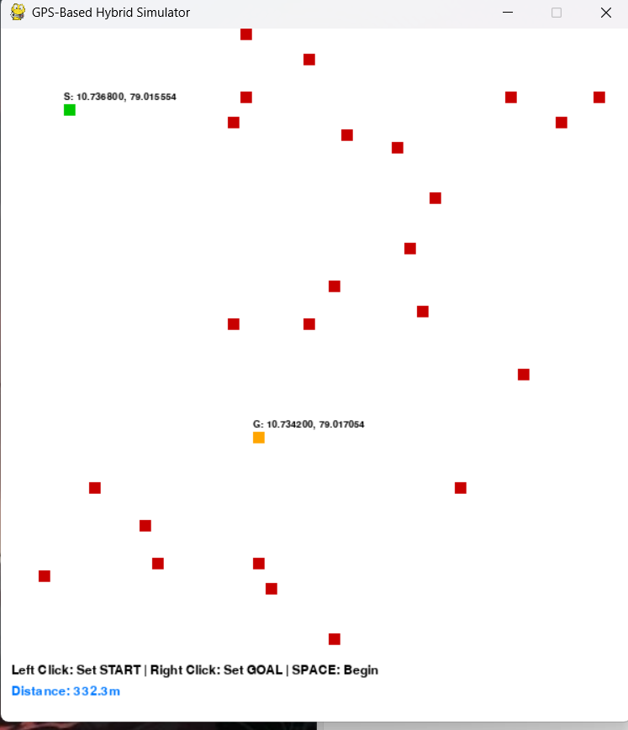

CHAPTER -7
CONCLUSION

The project demonstrates a cost-effective, real-time, GPS-based autonomous navigation system that intelligently selects and switches between multiple path planning algorithms. It forms a foundation for scalable robotics applications in outdoor and semi-structured environments.

CHAPTER-8
References

1.Bochun Cao; Zijing Yang; Lan Yu ( 2023 ) ; “Research on the A star algorithm for safe path planning “ Taken : Method of weight valuing in the heuristic https://ieeexplore.ieee.org/document/10141167
2. Dian Rachmawati and Lysander Gustin (2020) Analysis of dijikstra and a star algorithm in shortest path problem : Taken : “ Algorithmic steps of A star and dijikstra , results and conclusions “ https://iopscience.iop.org/article/10.1088/1742-6596/1566/1/012061/pdf 3.Rongli Cai (2024) : Unmanned Target Vehicle Navigation and Path Planning Using Improved Ant Colony Optimization Algorithm Combined with GPS/ BDS : Taken : Improving the design of Aco path planning model
4. S. Roy, S. G. N. Das, and M. Das (2021). "Dynamic Path Finding using Ant Colony Optimization." ◦ Application: Uses ACO for dynamic pathfinding, considering factors like distance, traffic congestion, and even air quality, using GPS data.
◦ Contribution: This paper shows how ACO can be adapted to highly dynamic problems by incorporating real-time updates and user feedback to find the best route based on multiple preferences.
◦ https:// www.researchgate.netpublication349371301_Dynamic_Path_Finding_u sing_Ant_Colony_Optimization
5. by Fujie Wang , Wei Sun , Pengfei Yan,Hongmei Wei and Huishan Lu (2024) : ‘ Research on Path Planning for Robots with Improved A* Algorithm under Bidirectional JPS Strategy ‘ Taken 2.1 Modelling of Gird maps and 2.2 Traditional A star algorithm
6. Peng Li ,Lei Wei and Dongsu Wu ( 2025 ) : “An Intelligently Enhanced Ant Colony Optimization Algorithm for Global Path Planning of Mobile Robots in Engineering Applications” Taken : 3. Environment model ant ant colony optimization
7. Xizheng Wang , Gang Li and Zijian Bian ( 2025 ) : “ Research on APF Dijkstra Path Planning Fusion Algorithm Based on Steering Model and Volume Constraints “ Taken : 2.2 Dijikstra’s algorithm optimisation and mapping
8. Guoqiang Wen, Zhiwei Guan, Hongxia Zhang, Rui Liu, Shuntang Hu & Ruzhen Dou ( 2025 ) : “ Path planning for autonomous vehicles based on the improved ant colony algorithm “ Taken : Principles of ant colony optimisation

